"Breaking Good" - Spring Mountain Vintners Celebrate Vintage

As each critical development phase in the vineyard occurred, the 2013 weather on Spring Mountain broke in favor of the winemaker presenting moderate, often ideal conditions for quality. As the new wines emerge from the fermenter, Spring Mountain District winemakers see promise.

“Just like late seasons, early growing seasons like 2013 can have their own weather hazards from bud break through ripening,” observed Tom Ferrell, Executive Director, Spring Mountain District Association. “As each critical development phase in the vineyard occurred, the 2013 weather on Spring Mountain broke in favor of the winemaker presenting moderate, often ideal conditions for quality. It was a season that gratified even the most persnickety winemaker.”

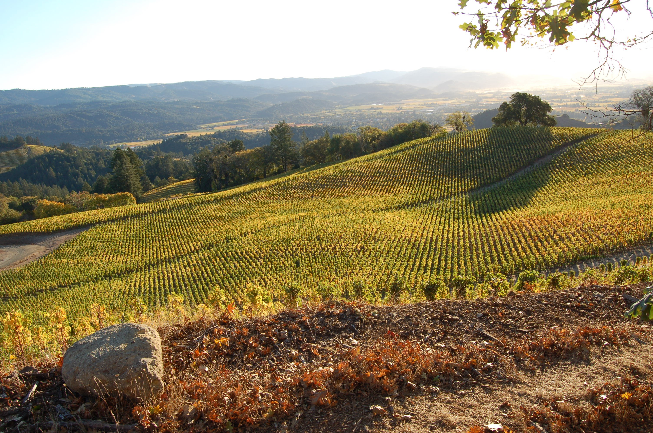
Speaking for the Spring Mountain District Association, the group’s President, James Leahy, observed, “Winemakers are never perfectly content with any vintage. It's never ideal, there is always something they would change. But this year, surveying our members, I was hard pressed to draw anything from Spring Mountain District winemakers other than praise for the fruit the vintage handed them.”

With the conclusion of the 2013 Spring Mountain grape harvest, its fate rests squarely in the hands of the winemaker. With high quality fruit, the winemakers are again challenged, but this year it’s in a good way.

Though still busy, some took time away from fermenting tanks, barrels, and celebrating to comment on the vintage.

Vineyard 7&8
“The 2013 harvest at the vineyard is sure to be remembered for a year with exceptional depth of flavor and concentration due to the small berries in our Cabernet Sauvignon. Although definitely an earlier finish to the harvest, the early start to the season led to optimal hang time needed to ripen the fruit, and develop the tannins.

"Currently all wines are completing fermentation, with the resulting wines showing amazing depth, concentration, superb color extraction and wonderfully smooth supple tannins. We are really looking forward to continuing to watch these young wines develop, and for another spectacular harvest here on Spring Mountain.” Wes Steffens, Winery Manager

Sarocka
“The 2013 harvest has been extremely kind to us at Sarocka. The season is the longest on record for the vineyard with near-extreme levels of hang-time in moderate weather. The resulting wines show incredible elegance with great depth and plush tannins. It is too early to say for certain exactly how things will turn out, but we are very happy at this point in time." Michael Hirby, winemaker.

Spring Mountain Vineyard
"Consistent, warm days and cool nights in September and October slowly brought the grapes to the perfect point of maturity when sugar levels and ripeness intersect. Despite a shorter duration of harvest, cooler temperatures in October fostered the hang time needed to achieve ideal balance that we already see in the 2013 wines. The 2013 wines are exceptional. Out of the fermenter, they show beautiful concentration and balance - a direct result of what we do in our vineyards. I can't wait to shepherd their development over the next two years." Patrick Sullivan, winemaker

Fantesca Estate
Winemaker Heidi Barrett summarized the harvest in one sentence. “Cooperative Fall weather allowed for picking the vineyard at optimum ripeness." Tony Arcudi, Associate Winemaker elaborated, “The 2013 growing season got off to an early start with a warm dry Spring, which then led to excellent conditions for fruit set. The Summer was generally warm and even with a few hot spells that hastened ripening a bit. Fall provided consistently warm to mild and dry conditions allowing the flavors to develop the fruit to be picked at ideal ripeness.”

Barnett Vineyards
“Although picking at Barnett Vineyards commenced on one of the earliest dates in our history, the fruit coming in has been exceptional. Two small showers posed no threat as the warm, dry days coupled with cool evenings made for an ideal 2013 harvest. Sugar levels outpaced flavor development for most of the season, but mild conditions in October allowed the latter to catch up. Overall, we saw smaller berry size, with above average yield on our estate. At this early stage, we are already seeing darker colors and more viscosity in the 2013 vintage wines." David Tate, winemaker

Schweiger Vineyards
“Harvest kicked off about two weeks earlier than normal. Throughout various vineyard blocks, ripeness was consistent, leading to a compressed and quick harvest season. A typical harvest at Schweiger Vineyards can last about 6 to 8 weeks start to finish; 2013 was about three weeks of intense work. There were two brief periods of barely perceptible rainfall during harvest this year, but in our situation, we wound up picking right before the first one, and finishing before the second one. Fortunately, all whites were in before these rains affected us.

"Overall, flavors and aromas are impressive with deep, intense color on all the Bordelaise varietals. Complex aromas and supple flavors are already developing in these young wines. Yields were about 15% below normal on Cabernet Sauvignon, average on Merlot, and a little above average on Chardonnay, Malbec, and Cabernet Franc.” Andy Schweiger, winemaker

Marston Family Vineyard
“The 2013 growing season delivered a vintage of power and concentration at Marston Family Vineyard. All indications suggested this would be an early harvest, with gentlemanly wagers being placed between our viticulturist and winemaker. Forecasts were confirmed when the grapes in our Albion program arrived roughly three weeks earlier than average; however, Mother Nature slowed things down for our hillside Cabernet Sauvignon and we picked in our typical window of mid-October with yields under 2 tons per acre.

"Although early, the bold character of the 2013 fruit hints at unbridled proclamations of depth and complexity. Restraint will be essential to guiding the sheer verve of this vintage, and to capture the underlying elegance that will be overshadowed in its youth. A close relative of 2012, these back to back vintages are heavyweights and worthy of the acclaim they are bound to receive.” James Leahy, Marston Family Vineyard

About the Spring Mountain District Association

The Spring Mountain District American Viticulture Area (AVA) was officially established in 1993. The appellation boundaries extend easterly from the top of the Mayacamas Mountains ridge line, which traces the Sonoma/Napa County border, down to the 400-foot contour line at the base of the hillside in the western limits of Saint Helena. The southern boundary follows Sulphur Creek and one of its tributaries while the northern boundary is Ritchie Creek. Elevations range from 400 to 2,600 feet, with a predominantly eastern exposure. Historically, the name Spring Mountain has been used in a regional context and does not refer to the name of a peak or prominent point. There are currently over 30 vineyards and wineries, encompassing 8,600 acres of mountain wilderness, of which about 1,000 are planted to vineyards.

Members of the Spring Mountain District Association are:

Andesite Vineyards, Atchley Vineyards, Barnett Vineyards, Behrens Family Winery, Cain Vineyard & Winery, Crowley Vineyards, Eeden Vineyards, Fantesca Estate & Winery, Frias Family Vineyard, Guilliams Vineyards, Hollywood & Vine Cellars, Juslyn Vineyards, Marston Family Vineyard, Newton Vineyard, Paloma Vineyard, Pride Mountain Vineyards, Ritchie Creek Vineyard, Robert Keenan Winery, Sarocka, Schweiger Vineyards, Sherwin Family Vineyards, Smith-Madrone Vineyards, Spring Mountain Vineyard, Terra Valentine, Vineyard 3646, Vineyard 7 & 8.

